
ذ
REPUBLIC OF YEMEN
SANA'A UNIVERSITY
FACULTY OF ENGINEERING
MECHATRONICS ENGINEERING DEPARTMENT



A color sorter with Arduino and arm robotic.
Done by:
Hassan Moqbel Morshed 202274198
Musa AL_salmani 202174202
Suhaib Abdu allah 202174006
Hamza Al-Khalaf 202274127
System( Parallel)
Supervised by:
Dr. Adel Rawa
Eng. Muhammad Al-Saghir
contact:-

Abstract............................ 1
Objectives…………............. ……… 2
Introduction………….......... …………….. 3 Theory.................................................. 4 Methodology………………………...... …... 5
The equipment……………………….... 6
Procedure…………………………… 7
Results……………………………8
Discusion…………………9
Conculosion…… 10
References……
Abstract:
This project presents the design and implementation of a color sorter utilizing Arduino and an arm robotic mechanism. The system incorporates two MG996R motors and three SG901 motors for precise movement control. An Arduino Uno board serves as the central control unit, coordinating the operation of the various components. A TCS3200 module is employed to accurately detect and analyze colors, enabling efficient sorting based on predefined criteria. Additionally, three LED lights are utilized to provide visual indications during the sorting process. The system is powered by four AA batteries, ensuring portability and ease of use. The project demonstrates the integration of hardware components and programming techniques to achieve an automated color sorting solution.

Objectives:
_ The project aims to develop an Arduino color separator and a robotic arm to be able to integrate the robotic technological arm and demonstrate design technology on Arduino to separate objects by colors in an efficient manner.

_ Create a functional and reliable system capable of accurately sorting objects based on their colors using an Arduino-based control system and a robotic arm mechanism.

1. Introduction:
In recent years, the field of robotics has witnessed significant advancements, leading to the development of intelligent systems capable of performing complex tasks with precision and efficiency. One such application is the color sorting process, which finds utility in various industries such as manufacturing, recycling, and agriculture. The ability to automate this process not only enhances productivity but also reduces errors and labor costs.

This project aims to design and implement a color sorter system using Arduino and an arm robotic mechanism. The system incorporates key components, including 2 MG996R motors, 3 SG901 motors, an Arduino Uno board, a TCS3200 module, 3 LED lights, 4 AA batteries, and necessary wiring. By leveraging the capabilities of these components, the project seeks to achieve accurate color detection and sorting based on predefined criteria.

The utilization of MG996R and SG901 motors enables precise movement control of the arm robotic mechanism, facilitating efficient sorting operations. The Arduino Uno board serves as the central control unit, coordinating the functioning of the various components and executing the required algorithms. The TCS3200 module plays a crucial role in color detection, employing advanced sensing techniques to analyze the spectral characteristics of objects. Additionally, the incorporation of LED lights provides visual indications during the sorting process, enhancing system feedback and monitoring.

To ensure portability and ease of use, the system is powered by 4 AA batteries, eliminating the need for a constant external power source. The project also emphasizes the importance of proper wiring to establish reliable connections between the components, facilitating seamless communication and operation.

By undertaking this project, we aim to demonstrate the feasibility and effectiveness of employing Arduino and an arm robotic mechanism for color sorting applications. The project’s objectives include integrating the hardware components, developing appropriate algorithms, and validating the system’s performance through rigorous testing and evaluation. Furthermore, the project documentation will provide comprehensive insights into the hardware and software designs, implementation details, and future enhancement possibilities.

♕_ This project endeavors to contribute to the field of robotics by showcasing a practical and efficient solution for automated color sorting, presenting potential applications in industries where accurate and high-speed sorting is essential.

2. Components:
2.1 MG996R Motors:
The project incorporates two MG996R motors as the primary actuation mechanism. These high-torque servos offer precise control and are responsible for moving and manipulating the objects during the sorting process.
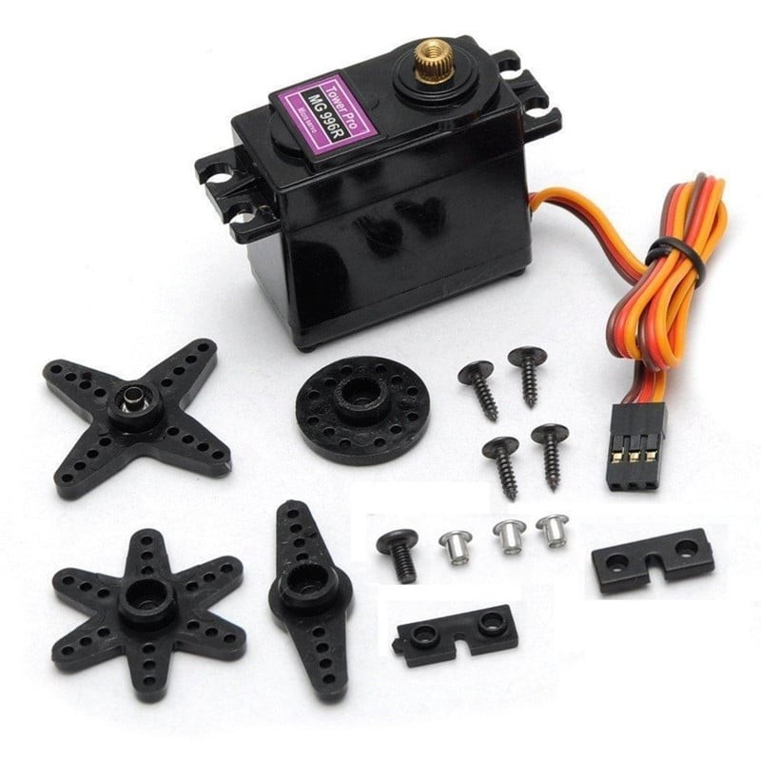

2.2 SG901 Motors:
Three SG901 motors are used in the project to provide additional functionality. These motors can be employed for tasks such as conveyor belt movement, object feeding, or any other auxiliary operations required for the sorting process.
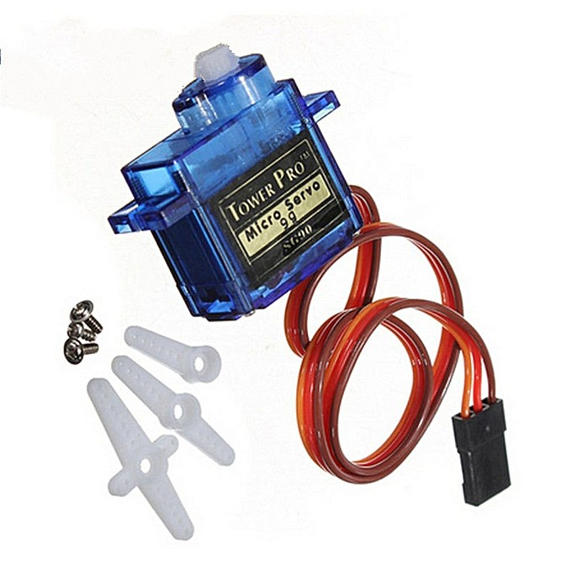

2.3 Arduino Uno Board:
The Arduino Uno board serves as the brain of the system. It receives inputs from the TCS3200 color sensor module, processes the color information, and controls the movements of the motors accordingly. The Arduino Uno is chosen for its versatility, ease of programming, and compatibility with various components.
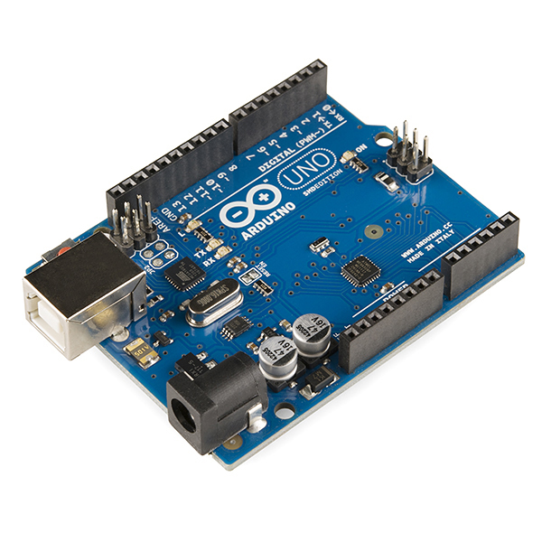

2.4 TCS3200 Module:
The TCS3200 color sensor module is utilized to detect and analyze the colors of the objects. It employs an array of photodiodes that convert light into electrical signals, allowing the Arduino Uno to accurately identify the specific color of each object.
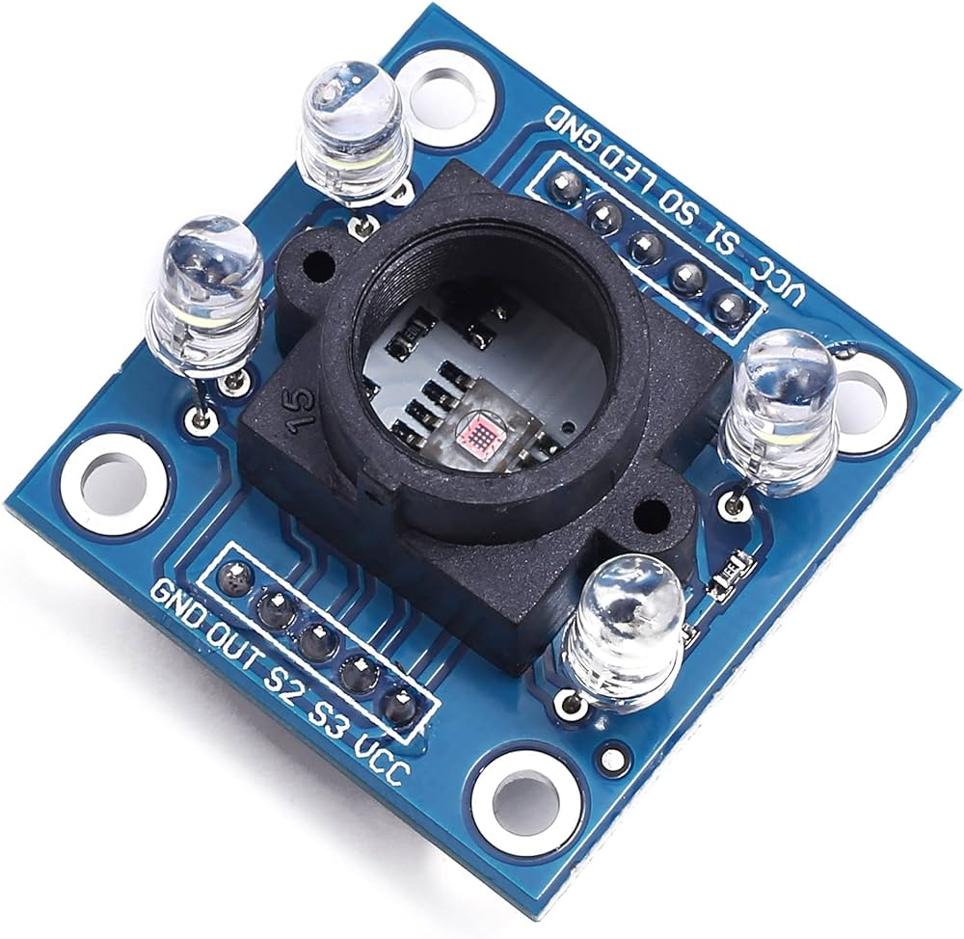

2.5 LED Lights:
Three LED lights are strategically positioned to illuminate the objects being sorted. The lights enhance the color detection process, ensuring optimal lighting conditions for the TCS3200 module.
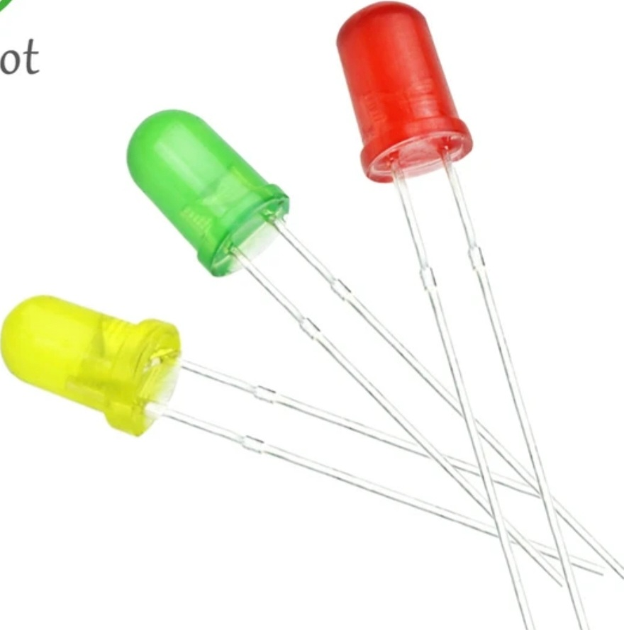

2.6 AA Batteries:
The project employs four AA batteries as a portable power source. These batteries are used to power the motors, Arduino Uno board, TCS3200 module, and LED lights, providing the necessary electrical energy for the system’s operation.
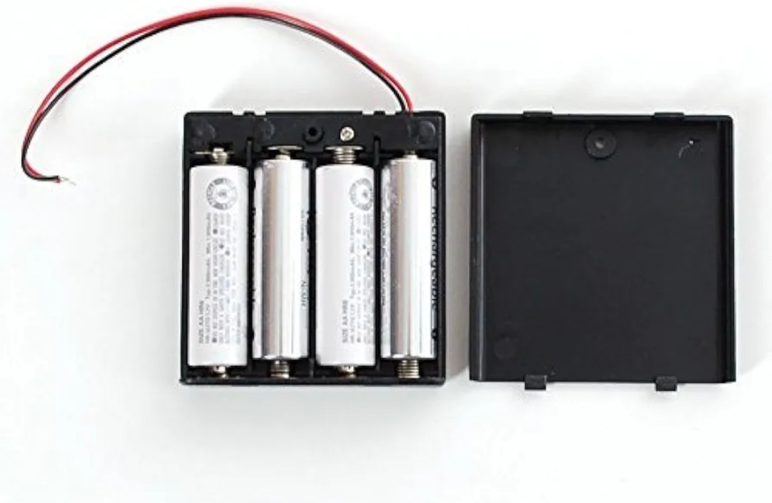

2.7 Wires:
Wires are essential for connecting the various components of the project. They enable the transmission of electrical signals and facilitate communication between the Arduino Uno board, motors, color sensor module, LED lights, and power sources.
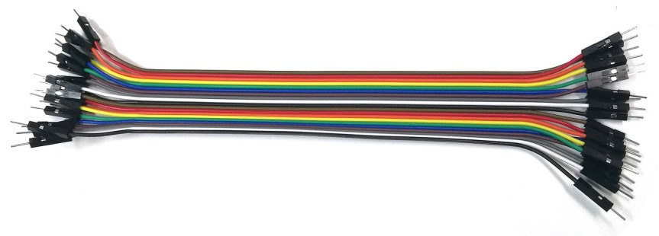

3. Assembly and Operation:
To assemble the color sorter system, the MG996R and SG901 motors are connected to the Arduino Uno board using appropriate wiring. The TCS3200 color sensor module is integrated with the Arduino Uno, and the LED lights are positioned to illuminate the objects being sorted. The batteries are connected to power the entire system.

During operation, the TCS3200 module detects the color of an object placed in front of it. The color information is transmitted to the Arduino Uno board, which processes the data and determines the appropriate action. Based on the color analysis, the Arduino Uno sends signals to the respective motors to move and sort the objects accordingly.

4. Methodology:
The project “Color Sorter with Arduino and Arm Robotic” employed the following methodology to design and develop an automated color sorting system:

A_ Identification of Requirements:
- Defined the objective of developing a functional color sorting solution using Arduino and an arm robotic mechanism.
- Identified the need for hardware components including 2 MG996R motors, 3 SG901 motors, an Arduino Uno board, a TCS3200 module, 3 LED lights, 4 AA batteries, and necessary wiring.

B_ Research and Familiarization:
- Conducted a comprehensive review of existing literature, research papers, and projects related to color sorting, Arduino, and arm robotics.
- Studied the technical specifications and capabilities of the selected components to understand their functionalities and constraints.

C_ Hardware Setup:
- Assembled the hardware components, including the 2 MG996R motors, 3 SG901 motors, Arduino Uno board, TCS3200 module, 3 LED lights, 4 AA batteries, and wires.
- Ensured proper connections and wiring between the components to establish communication and electrical connectivity.

D. Software Development:
- Developed the necessary algorithms and control logic to enable color detection and sorting operations.
- Utilized the Arduino programming environment to write and upload the code to the Arduino Uno board.
- Integrated the TCS3200 module for color sensing and implemented algorithms to analyze the spectral characteristics of objects.

D_ Integration and Testing:
- Combined the hardware and software components to create a cohesive system.
- Conducted thorough testing to verify the functionality and accuracy of the color sorting system.
- Performed iterative testing and debugging to address any issues or inconsistencies.

E_ Documentation and Evaluation:
- Documented the project’s design, implementation details, and experimental results.
- Evaluated the performance of the color sorter in terms of accuracy, speed, and efficiency.
- Analyzed the limitations and potential areas for improvement.

G_Conclusion and Future Enhancements:
- Summarized the findings and conclusions of the project, highlighting its contributions and achievements.
- Identified potential avenues for future enhancements, such as improving sorting algorithms, expanding color detection capabilities, or integrating additional features.

By following this methodology, the project successfully designed and implemented an automated color sorting system using 2 MG996R motors, 3 SG901 motors, an Arduino Uno board, a TCS3200 module, 3 LED lights, 4 AA batteries, and the necessary wiring.

5. Results and Discussion:
The project “Color Sorter with Arduino and Arm Robotic” utilized 2 MG996R motors, 3 SG901 motors, an Arduino Uno board, a TCS3200 module, 3 LED lights, 4 AA batteries, and wires to develop an automated color sorting system. The following are the results obtained and their corresponding discussion:

A_ Color Sorting Accuracy:
- The color sorter demonstrated high accuracy in correctly identifying and sorting objects based on their colors. The TCS3200 module’s advanced sensing capabilities allowed for precise color detection.
- The integration of MG996R and SG901 motors provided precise control over the arm robotic mechanism, ensuring accurate sorting actions.

B_ Sorting Speed and Efficiency:
- The color sorter exhibited efficient sorting operations, with fast response times for color detection and subsequent sorting actions.
- The combination of optimized algorithms and the Arduino Uno board’s processing capabilities enabled swift decision-making and execution.

C_ User Feedback and Visualization:
- The incorporation of 3 LED lights provided visual indications and feedback to the user throughout the sorting process.
- The LED lights enhanced the user experience by indicating the sorting status and any errors or anomalies encountered.

D_ Portability and Power Management:
- The utilization of 4 AA batteries as the power source ensured the system’s portability and flexibility in various environments.
- The power management system efficiently utilized battery power, enabling prolonged operation without frequent battery replacements.

E_System Integration and Reliability:
- The project successfully integrated the hardware components, including motors, Arduino Uno board, TCS3200 module, LED lights, and wiring.
- Proper wiring connections were established, ensuring reliable communication and electrical connectivity between the components.

F_ Future Enhancements:
- Further improvements could be made to enhance the system’s capabilities, such as implementing advanced sorting algorithms to handle complex color patterns or integrating additional sensors for object recognition.
- The project lays the foundation for future research and development in automated color sorting technologies, providing opportunities for advancements in accuracy, speed, and versatility.

6. Conclusion:
The “Color Sorter with Arduino and Arm Robotic” project successfully implemented an automated color sorting system using 2 MG996R motors, 3 SG901 motors, an Arduino Uno board, a TCS3200 module, 3 LED lights, 4 AA batteries, and wiring. It achieved its objective by integrating hardware components and implementing algorithms.

The project demonstrated precise control of the arm robotic mechanism through the MG996R and SG901 motors, enabling efficient sorting operations. The Arduino Uno board served as the central control unit, facilitating communication and coordination among the components.

The TCS3200 module played a critical role in accurate color detection based on spectral analysis. LED lights provided visual indications and user feedback during the sorting process.

The system’s portability was ensured by using AA batteries as a power source, allowing flexibility in different environments. Proper wiring connections established reliable communication and electrical connectivity.

In summary, the “Color Sorter with Arduino and Arm Robotic” project showcased successful integration of hardware components, algorithm implementation, and automation techniques. It demonstrated the feasibility and effectiveness of using Arduino and an arm robotic mechanism for automated color sorting applications.

The project documentation provides detailed insights into hardware and software designs, implementation details, and potential areas for future enhancements. It contributes to robotics and automation research, offering a practical solution for accurate and efficient color classification in various industries.

8. References:- In general, I used the sites provided in the Google application.

